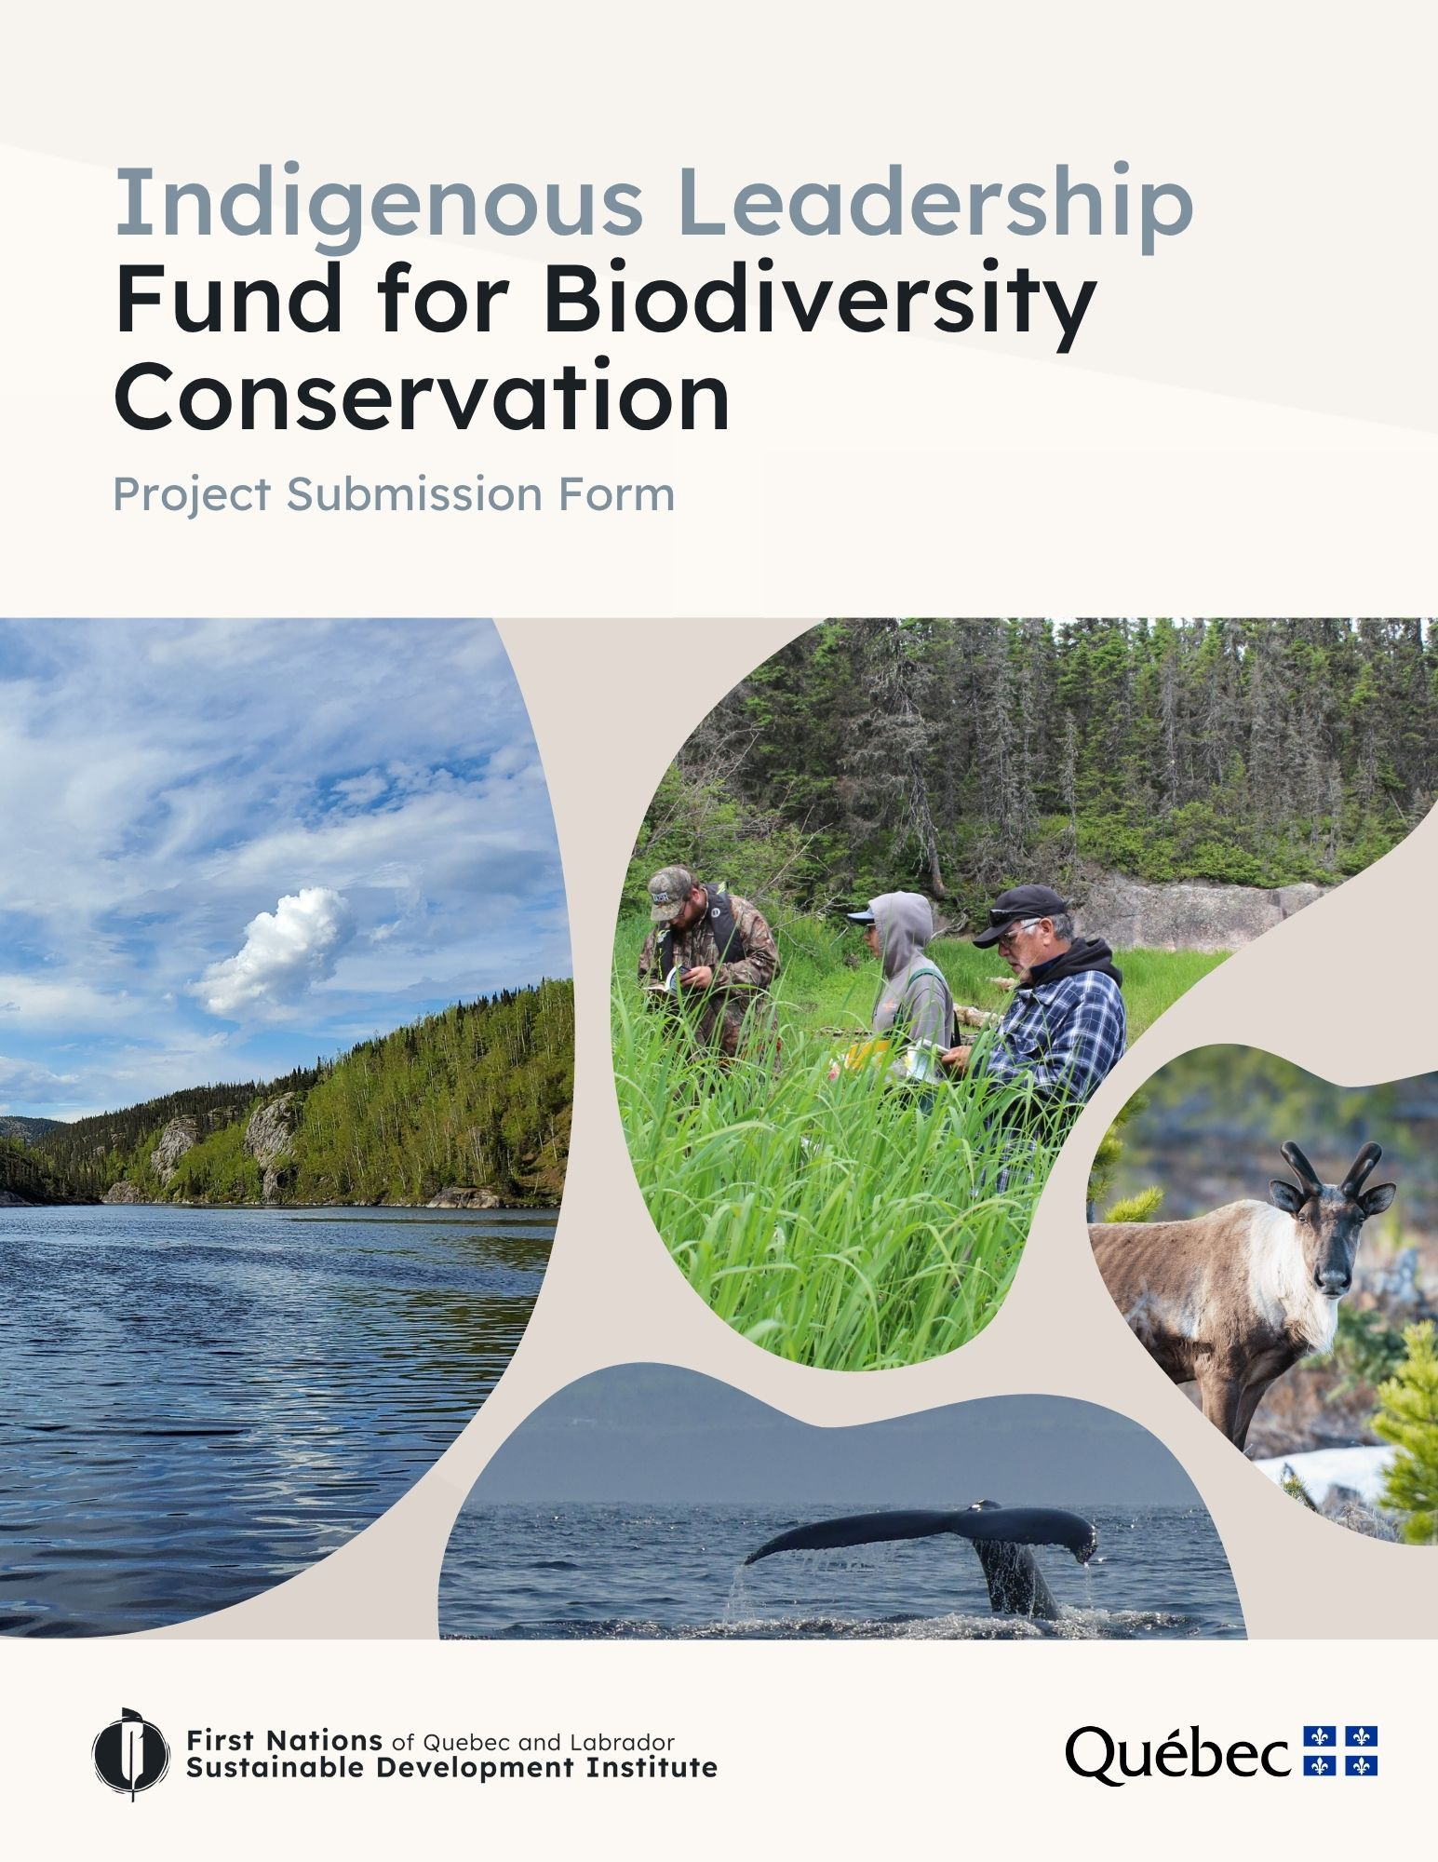
Use of this template is mandatory to facilitate the drafting and submission of your proposal, and to facilitate the analysis of the applications received.
Before you start writing your proposal, we invite you to familiarize yourself with the Applicant's Guide.

Need help?
We are available to help you develop and prepare your project proposal, as well as throughout all stages of its implementation.
For further information, please contact Mélissa Martel, Conservation Project Leader, at leadership@iddpnql.ca.
You can also call us at 418 843-9999.

Information on the organization responsible for the project

Project title :

Organization/community(ies) submitting the project:
Address and zip code of organization/community(ies):

Mission of the organization/community(ies):

Company number :

Contact name : | Add several contacts if necessary
Title/position of contact person(s):

Contact information : | Enter your e-mail address and telephone number
Amount requested :

Estimated project start and end dates :

Project Application Form

- Verification of eligibility criteria

Please indicate that your request meets the following eligibility criteria:
☐ Eligible organization or applicant (refer to Appendix 1 of the Applicant's Guide - eligibility criteria)
☐ Complete proposal :
- All sections of the form are duly completed
- Identification of Nature Plan 2030 targets to which the project contributes
- Work plan with deadlines
- Preliminary budget
☐ The amount requested is equal to or less than the established maximum
☐ The project can be completed before March 31, 2029

2. Project information

2.1 Project title

2.2 Brief description of the project
Describe the project and how it relates to the organization's mandate (max. 200 words).

How important is it to your community? (Max 200 words)

2.3 Background and history
In what context will your project be carried out? (Max 300 words)
- Are there any other similar or complementary initiatives already underway in the region?

- Is your project a continuation of a previous one? If so, briefly explain the previous project and how it relates to your project.

2.4 Indigenous leadership and 2030 Nature Plan targets
Identify the target(s) of the 2030 Nature Plan for your project. Consult the 2030 Nature Plan summary for more information on the targets.
Main Project Targets:
☐ Target 1: Regional planning
☐ Target 2: Restoration
☐ Target 3: Protected areas
☐ Target 4: Threatened and vulnerable species
☐ Target 5: Invasive alien species
☐ Target 6: Agriculture
☐ Target 7: Forestry
☐ Target 8: Sustainable use and access to nature
☐ Target 9: Governance
☐ Target 10: Private sector
☐ Target 11: Sustainable consumption
☐ Target 12: Financing biodiversity
☐ Target 13: Indigenous leadership
☐ Target 14: Mobilization

Secondary targets of the project:
☐ Target 1: Regional planning
☐ Target 2: Restoration
☐ Target 3: Protected areas
☐ Target 4: Threatened and vulnerable species
☐ Target 5: Invasive alien species
☐ Target 6: Agriculture
☐ Target 7: Forestry
☐ Target 8: Sustainable use and access to nature
☐ Target 9: Governance
☐ Target 10: Private sector
☐ Target 11: Sustainable consumption
☐ Target 12: Financing biodiversity
☐ Target 13: Indigenous leadership
☐ Target 14: Mobilization

Explain how the project will contribute to achieving the identified targets (Max 300 words)

2.5 Project objectives
What are the short-term and long-term objectives of the project? (Max 300 words)
Your objectives must respect the SMART principles: specific, measurable, achievable, relevant and time-bound.

What methodology will you use to achieve your goals? (Max 200 words)

2.6 Community, economic and cultural aspects
Describe how your project contributes to improving the collective, economic and cultural aspects of your community and its territory. (Max 300 words)

- How will your project enhance your community's knowledge?

- How will your project showcase your culture?

- Will your project generate economic benefits for the community, such as job creation? If so, which ones?

2.7 Participatory approach and capacity building
Explain how your project will involve your community or organization. (Max 300 words)
- To what extent will your project promote the development of skills, knowledge and competencies in your community or organization?

2.8 Project feasibility
The purpose of this section is to identify your project's strengths and weaknesses, present the issues that could threaten its realization, and identify ways of mitigating them. (Max 300 words)

- What are the challenges you may face during your project? What means have you put in place to deal with them?

- What human, financial or material resources do you need to carry out your project?

2.8.1 Partnerships (Optional question, Max 200 words)

How do your partners intend to support your project?

2.8.2 Social acceptability (Max 200 words)

- Which regional players might oppose your project? Which regional players might support your project?

- Have you consulted, or do you plan to consult, with stakeholders inside and outside the community? If so, please describe the steps taken to date or those planned as part of the project.

2.10 Project deliverables, benefits and scope (Max 300 words)
- What are the deliverables and anticipated benefits of your project?
- What will be the long-term impact of your project?

2.10.1 Project impact (Max 150 words)
- How do you plan to promote the project to your community, external stakeholders and the general public?

3. Preliminary work plan and timetable
This is the work plan template to be used when submitting your project. It illustrates how you will achieve your project objectives by describing the major milestones and planned activities. You can insert additional lines in the table as required.

Activities |  | Description of activities | Start and end dates | Anticipated results and deliverables
1 | Example:  Project coordination | Example:  - Starting recruitment  - Hiring a project manager  - Train a project manager | Example:  October to November 2025 | Example:  - Employee hired and trained
2 | Example:  Floristic inventory | Example:  - Drafting a data collection protocol  - Collecting data to identify the presence of a species with special status  - Analysis of collected data | Example: January to September 2026 | Example:  - Data collection protocol  - Summary inventory results
3 | Example: Consultation with regional players | Example:  - Draw up a list of players to meet  - Planning consultation meetings  - Organize and lead consultation meetings | Example: November 2025 to October 2027 | Example:  - List of stakeholders  - Minutes of consultation meetings

4. Project Team Information
Indicate the name of the person in charge of the project and describe his/her experience in relation to the project. Use the table to introduce the other team members who will be involved in the project. If you don't yet know who the project team members will be, you can indicate "to be determined" and explain how you will go about appointing them. You can add rows if necessary.
Name, title and experience of project manager (Max 200 words) :

Name and title of team members | Organization | Role in the project

5. Information on external partners
Give details of anyone else who will be involved in the project. For example, university researchers, consultants, non-profit organizations, municipalities, etc. You can add more lines if necessary.
Organization | Role in the project | Letter of support (yes/no)

6. Budget

You will find an Excel file illustrating a provisional budget template by following this link.

7. List of documents to enclose

☐ Map of project area - identification of project location on a map (if applicable)

☐ Letters of support (please list letters attached) *optional
- Letter of support 1 :
- Letter of support 2 :
- Letter of support 3 :

☐ Resolution of a Board of Directors or Band Council, if the project is submitted by an NPO or Band Council

☐ Preliminary budget (use mandatory template)

☐ Other : _______________________________________________________

